Batch Processing

Communication Completion

User Guide

The Communication Completion file is used for marking existing Communications as completed, that weren’t marked as complete previously. The input file for Batch Communication Completion is an Excel spreadsheet, saved as a .csv file. The input file contains a Header row and a Column Headings row. The input rows follow.

Header row – Data is as follows:
Column A – will always be the value “HD”
Column B – Institution Code (IUBLA, IUINA, etc).
Column C – User’s Department
Column D – User’s Name
Column E – User’s Email Address

Column Headings row – description of column heading are shown in the Input Rows section, along with their corresponding column.

Each Communication Completion will consist of one input row.

Input rows – ALL ALPHA DATA INPUT MUST BE IN ALL CAPITAL LETTERS.

Emplid (column A) – System ID

Sequence Number (column B) – Sequence number of Communication on the record that you want to mark as complete.

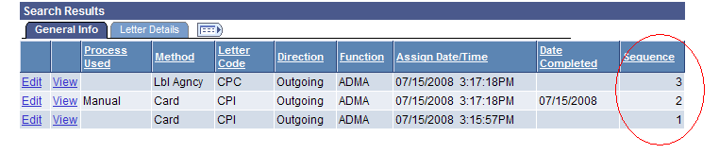

SA ID Type (column C) – valid values are P (Person), O (Organization), or N (Neither); will default to P unless input was zero, in which case the program assumes ‘O’ is meant

Completed Emplid (column D) – emplid for person completing the Communication; will default to CCMPPRCS if no input provided

Completed Date (column E) – will default to system date if no input provided

Example input:
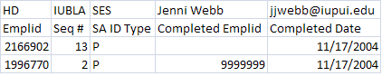
BEWARE!

This batch job does NOT run an edit to see if either the Communication Completed checkbox or Unsuccessful Outcome checkbox has been previously checked.

If the Communication Completed checkbox has already been checked, this program will overwrite the existing data.

If the Unsuccessful Outcome checkbox has already been checked, this program will also check the Communication Completed checkbox and post the incoming data.

Be sure that you are updating the appropriate Sequence Numbered Communication!

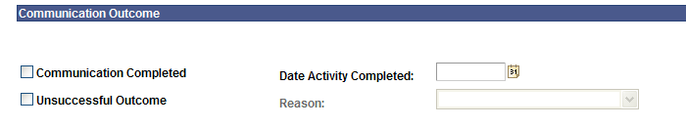

Save Files

User will save Excel file as a .csv file. Change ‘Save as type’ field to CSV (Comma delimited)(*.csv). Format for file name is iu_3c_all_comm_comp.*.csv. The wildcard (*) can be any descriptive text. Please do NOT include any spaces or special characters (underscores and periods are allowed).

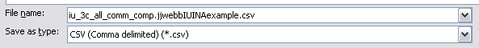

You will also need a .recon file containing the total number of rows of input in the .csv file (including the 2 header rows). If you have 2 rows of actual input (as in the example shown above), and you have 2 header rows, then your .recon file should contain a value of 4. Include a hard return after the data (press the Enter key once). If the user doesn’t create a .recon file, the processor will need to do this before submitting the files to DTP.

Using Notepad, create the file.

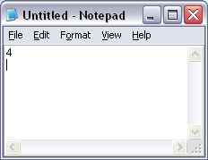

Change ‘Save as type’ to ‘All Files’. Save file as iu_3c_comm_comp.*.recon. The wildcard portion of the file name must match the wildcard portion on the .csv file.

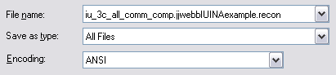

Drop Files to Folder

Drop .csv and/or .recon files into \\ADS\USSS\Campus_Community_Batch_Loads_RC\Batch_3Cs. Drop the files by 12 Noon to guarantee same-day processing. Any files dropped after 12 Noon may possibly not be processed until the following business day.

Questions
Send any questions to SES-BatchProcessing@exchange.iu.edu.

Mapping

You may need to map a new drive to \\ADS\USSS.

